PROJECT MANAGEMENT PLAN
GETTA BYTE SOFTWARE
Dionte’ Bell
DeVry University
08/01/2020

Table of Contents
SECTION A 5
GETTA BYTE 5
INTRODUCTION 5
PROJECT PURPOSE 6
PROJECT DESCRIPTION AND PROJECT PRODUCT 8
OBJECTIVE 8
MILESTONES 9
BUDGET 9
USER ACCEPTANCE CRITERIA 10
HIGH-LEVEL PROJECT ASSUMPTIONS 10
HIGH-LEVEL PROJECT CONSTRAINTS 11
EXCLUSIONS AND BOUNDARIES 12
MAJOR RISKS 13
KEY STAKEHOLDERS 14
APPROVALS 14
SECTION B 14
STAKEHOLDERS MANAGEMENT 14
SECTION C 15
COMMUNIACTION MANAGEMENT PLAN 15
SECTION D 15
GETTA BYTE SOTWARE PROJECT SCOPE STATEMENT 15
Role 17
Quantity 17
Estimated Length of Time 17
Expense Type 19
Description 19
Estimated Cost 19
.The developers will create the program needed 19
Total Estimated Cost of Project 19
$250,000 19
Accurate customer information 19
SECTION E 19
WBS 19
SECTION F 21
Gantt Chart 21
Budget Cost 22
SECTION G -----------------------------------------------------------------------------------------------------------------------27

Risk Register ………………………………………………………………………..27
Conclusion ………………………………………………………………………………………………………………………………..27

References 24

Project name | Online billing system | Project number | Group B
Project team | Mate Atkins, Bruno Fernandez, Jose Philippe, Adams Scotts | Prioritization | Immediate
Owners | Getta Byte Software | Start date | August 15th 2020
 |  | Stated completion date | September 10th 2020

SECTION A

GETTA BYTE

INTRODUCTION

Getta byte for many years has been employing the use of billing system in making sure that the transaction is we completed and, at the same, ensured that the customer's payments are well documented and the money submitted into the clients' accounts. Therefore, the billing system can be considered to mean a link between software and hardware that is specifically designed to ensure that service usage information and call details are well received. They also play a part in ensuring that a group of information is well stored for given clients' accounts. This billing system is also the role of ensuring that invoices are produced, reports created for the management, and payments recorded. For some time now, the Getta Byte has been employing this method in their system for quite some time, and they have realized that the current billing system is not accurate, and at the same time, it is time-consuming. This is why they decided to focus on an online billing system that will try to solve this kind of challenge. For any firm, accuracy and time factor are essential for the running of the business‌ (A Howard Metro, Mininsohn, Shellenberger, & Institute, 1989).
The firm is trying to work hard to solve this issue so that it can offer a trusted and effective service to its clients who mostly have project goals that align with the company's mission statement. The Getta byte is flexible in leading both small and large scale efforts, and it has also come up with a portfolio that is well recognized with the clients and the community at large. The look into the billing system is designed mainly for the benefit of the firm and the clients. A company needs to be sure of the billing system if they don't want to mess with the customers; the online billing system will be the best solution for many firms‌ (Hubbard, 2003).

PROJECT PURPOSE
The primary purpose of this project is to solve the issue that many companies are undergoing while trying to fix the problems on the matter related to customer handling and detailed recording of both the company and the customer. Considering the current billing system, that company came into the realization that the system consumed most of the time and, at the same time, was not accurate. Misinformation resulted in the long run, and it could affect the company's operations if they are not well handled. Therefore, the online billing system came to solve this kind of issue by ensuring that accuracy and time spent in coming up with clients' reports are short. And the online billing system is growing at an alarming rate, and it is a technology that has been embraced by many corporate departments. The billing system is after ensuring that both the company and the customer are benefiting from accurate and well-defined information.
Getta Byte was introduced by an entrepreneur whose main idea was to solve the issue that arises in billing information where clients could be served with ease without wasting most of the time handling one client. To ensure that the set goal was achievable and at the same time practical, the entrepreneur came in with expertise of and online billing system that could solve this kind of issue. The firm will see to it that all the needed resources are provided to solve such a problem once and forever. The online billing system's development is to accomplish and change the way companies work and document their essential information and finances (Erl, Puttini, & Mahmood, 2013).
The company's objective is to ensure that customer satisfaction is a top priority in the business. Thus, coming up with an online billing system will ensure that the customer is satisfied with the kind of service and information they receive from the corporate. Customer satisfaction will help the business grow into another level. Through a recommendation, it is clear that many companies will benefit if they focus on delivering the best to their clients. It is also the desire of any company to grow its name over a short period, and this can only be achieved through a commitment to the company's objective. Following the client's guidelines is also very important in helping understand the areas of improvement. The company can run, but without a proper strategy, the chances of growing and expanding are minimal. The company's goal is to evolve from offering services to local clients and provide services to international clients. It even into coming up with speed internet access to ensure that the services provided to the customer are fast. An online billing system is brought in to ensure continued prosperity and a positive rating from clients.
The online billing system is part of the project to make sure that the users enjoy the kind of service they are offered. It plays a role in ensuring that the company does not incur losing at the expense of the current billing system. Continue use of the current billing system will see to it that customers flock in numbers to complain about the services, which will affect the reputation of the company. Solving the issue is a step that would guarantee excellent service rendered to the clients. In this era, it is clear that most of the customers and businesses are moving with technology. Therefore, it will only be effective if the company moves from old to new technology, which is at an increased speed and development compared to them later. Competitive advantage comes in as a result of focusing on what is essential for the company and the kind of services offered. To beat the competitive market, the company must focus on the upgrade of the billing system to enhance customer retention and absorption. With the company's growth, it is evident that most of the people will be embraced into the company, and they will also extend their hands to offering internships to students who specialize in software and hardware.

PROJECT DESCRIPTION AND PROJECT PRODUCT
The project will create room for improvement in the billing system and help solve the issue of time management and accuracy. It will create a conducive working environment for both the employees and the clients. The kind of product that comes out of this project includes the software and hardware that drive the billing system into functioning well without errors. Getting to know how the online billing system work will be essential in helping complete the assigned task by the client. Having the information on how the system works in a significant way will make things easier when it comes to operations. The deliverables that will be as a resulting of the online billing system will;
- Getting clear access to all the billing representatives
- Capabilities in auditing
- Faster working environment
- High accuracy level
- And an efficient working environment.

OBJECTIVE
The objective of these projects is to meet the clients' requirements by making sure they are well served and handled. It is also after making sure that the time spent managing the customer is reduced by employing the use of an online billing system‌ (Rittinghouse, 2010). Also, accuracy is of the essence when it comes to the company's objective. This is to avoid any error that may be as a result of the current billing system. Customer satisfaction is of great essence, and making sure they leave corporately satisfied is the company's main objective. Also, apart from that, it is the company's objective to ensure the expenditure cost is reduced by thirty percent from the original expense at 450 dollars in a month. The goals that are needed to meet the stated objective include;
- Conducive working environment
- Committed team members
- Internet accessibility

MILESTONES
A project's milestone can be defined as a time frame in which a project begins and the changes that come with it.
Milestones | Estimated Date of Completion
Project Document  Requirement Complete  Payment of the software  Software fully customized  Training done  Handing Over | 10/08/2020  25/08/2020  27/08/2020  15/09/2020  05/10/2020  25/09/2020

BUDGET
Estimated labor | $50,000
Estimated materials | $50,000
Estimated contractors | $50,000
Estimated equipment and facilities | $100,000
Estimated travel | $250
TOTAL ESTIMATED COST | $275,000

USER ACCEPTANCE CRITERIA
The minimum success criteria by stakeholders include resources working in the right project, the planned investment, the capital cost is on target, and the expense cost is on target. To monitor and measure the project's quality, the best thing to employ is ensuring that all the stated budgets are followed and that everything that is stated is acquired without having to outdo even one of the said. The project owners can easily estimate the project's success by looking at the expense cost and if all the said material and equipment are in place. The owner will make a comparison between the actual current spending to what the manager had budgeted. If there is a variance between the two, it means that the manager has the right to doubt and make inquiries. They can also measure the project's success by following the schedule, a project has a stipulated time of completion, and if these are not met, then it is clear that the owner will have to ask why that is. If it is completed at the stated time and date, then it is clear that it is a success. The third way in which the owner can measure the success of the project is through quality. The owner has the mandate of checking if he/she is satisfied with the work. If the owner is happy, it means that the work is done well. Also, the stakeholder's opinion is critical, the owner can seek advice concerning the project from the stakeholders, and if they are okay, it means that the project is well done.

HIGH-LEVEL PROJECT ASSUMPTIONS
Any given business works with assumptions before they start; they try to think of how the project will be and how they can take to make the project a success. Assumptions are the project factors that are considered to be accurate and confident, and at the same time, real.
- The project will be completed within a stipulated time
- The materials will be available when they are needed
- Contractors will deliver a perfect job for the project
- The team members for the project will have the necessary skills
- All the relevant stakeholders will be available for the meetings
- All the materials and equipment will be in an excellent working condition
- Suppliers will deliver the consumable on time
- The estimated budget will not exceed
- The project completion will be a success
- Parking will be readily available for the clients
- Health and safety inspection will be passed
- Security cameras and services will be available for the customer's safety.

HIGH-LEVEL PROJECT CONSTRAINTS
Constraints are those factors that may hinder a business from achieving its stated goal and objective. Limitations are usually drawn backs that can stop a project from going to completion. Having considered all the set rules, regulations, law, processes and procedures some other constraints affect the project from reaching its end, and some of the high-level limitations include;
- Risk- managing risk in any project is very important since the threat can halt the project. Uncertainty may arise in the project, and thus ensuring that they are handled is very important for the success of the project. In every project, risk comes; first, nothing comes without having to risk, and therefore risking is part of the project, but if controlled, it results in success. The stakeholders are mainly worried if the supplier will deliver; they are also concerned if the market takes a huge swing.
- Cost may also be a hindering factor for the completion of the project. Before starting a project, the owner needs to ensure that he consider cost first.
- When coming up with a project, everyone will want something that is of high quality, and thus having a plan in place is essential in coming up with excellent quality. Quality is paramount, and it should be the priority of the project before it commences.
- Customers, it is something to come up with a plan and convincing the clients into the business. In most cases, handling of the clients plays a significant role in ensuring that the business grows.
- Time is also another constraint that most stakeholders consider and worry about. The project is given a particular time before it is completed, and therefore the stakeholders will be assured of the stated date. In case it is not completed, it results in a challenge since the stakeholders need to revisit the plan and understand why the project isn't complete.
- State and county business permits and licensing.
- Opening day of the business and the day of completion

EXCLUSIONS AND BOUNDARIES
Because many businesses are in place, competition is very sensible. Direct competition comes from the nearby business that is involved in the same project. The possible exclusion may include;
- 24 hours operation may not be feasible due to revenue and labor cost
- The companies’ signage may not be according to the signage code
- The parking space may limit the business space
- The expansion of three or more business rooms may be achieved or not achieved due to the company's success and failure.
- Limited site work from Monday to Friday
- Owners responsible for landscaping
- Installation and operating permits
- Introduction of a new billing system
- Internet accessibility challenges
- Operating hours

MAJOR RISKS
In the billing system there is some risk that may result before the project starts and some of the significant risks include;
- Financial challenges
- Installation difficulties
- System risk due to inexperience in installation
- Hard to get to know how the system works
- Problems to connect through the internet
- Compatibility challenges
- Anxiety in understanding issues that comes with the system

KEY STAKEHOLDERS
Project Manager Authority Level | Mate Atkins
Project Core Team | Mate Atkins, Bruno Fernandez, Jose Philippe, Adams Scotts
Subject Matter Experts (SMEs) (What resources will you need with special expertise?) | Auditing in accountancy and consultation by Getta Byte software  Banking services and financial risk management by Northern Trust corporation

APPROVALS
TYPE NAME | SIGNATURE | DATE
Project Manager Approval | Mate Atkins, | 18TH August 2020
Customer/Sponsor Approval

SECTION B

STAKEHOLDERS MANAGEMENT
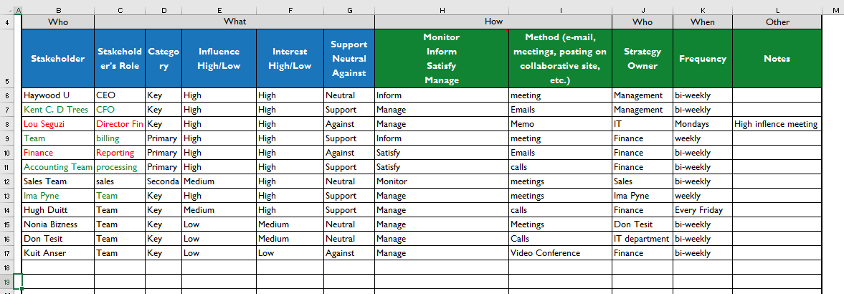

SECTION C

COMMUNIACTION MANAGEMENT PLAN
Communication is essential in any given institution. It drives the company into having a good relationship between the top management and the employees. Through discussion, most of the goals are achieved quickly, considering that the employee can be free to share their thoughts with the control without fear (Holper & Csiro (Australia). Division of Atmospheric Research, 1996). Management not involving in communication with the employee will result in the slow growth of the company. The connection gives way forward of the company to take a step towards achieving the set objective and goals.

SECTION D

GETTA BYTE SOTWARE PROJECT SCOPE STATEMENT
Project Name | “Getta Bill” | Date | June 1st
Project Number | GB-Unknown | Student Name

Project Description
The Getta byte software is a new kind of cloud-based system that is very fast and easy to use to ensure there is a reduction in the billing error by15%.

Project Requirements
The system will enhance billing process in many organizations. It will capture audit and perform billing using the online platform

Project Deliverables
Requirements design of the system.
Functional requirements of the system
Implement all billing functionality and allow customization

Project Does Not Include (Exclusions)
Upgrades to the accounts receivable system or changes to the financial system of record

Acceptance Criteria
The product must be easy to use
The design should meet 70% customer requirements.
Software customization must meet 80% of the requirements.
Improve transaction speeds by at least 30%
Allow for dynamic reporting
Reduce billing errors by at least 30%
100% replacement of the current billing system with a cloud based system

Estimated Project Schedule
Milestones | Estimated Date of Completion
Project Document  Requirement Complete  Payment of the software  Software fully customized  Training done  Handing Over | 10/08/2020  25/08/2020  27/08/2020  15/09/2020  05/10/2020  25/09/2020
Total Estimated Length of Project

Resource Requirements
Role | Quantity | Estimated Length of Time
Data Designer | 1
Designers | 2
Billing representatives for testing | 3+
Project Manager | 1

Project Deliverables
A more effective and efficient working environment
A faster and accurate working environment
Having the capabilities of auditing
Getting through the billing representatives by having system access.

Estimated Cost of Project
Expense Type | Description | Estimated Cost
Developers | .The developers will create the program needed | $50,000
Data Specialist |  | $50,000
Software Purchase |  | $100,000
Project Manager | The Project Manager oversees the success of project | $50,000
Total Estimated Cost of Project |  | $250,000

Project Constraints
Budget and schedule
Project Assumptions

Accurate customer information
No troubleshooting with new network needed

SECTION E

WBS
WBS | Phase & Task Descriptions
1.0 | Phase I - Initial Project Tasks
1.1 | Project Proposal
1.2 | Project Approval by Firm Management
1.3 | Notify Stakeholders Approval
1.3 | Stakeholder and Project Management Firm - Kick off meeting
1.4 | Project documents (Project charter, business case)
2 | Phase II – Requirement finalizing
2.1 | User requirement gathering
2.2 | Customer requirement gathering
2.3 | Requirement Complete
3 | Phase III – Software purchase
3.1 | Choosing a vendor
3.2 | Price negotiation
3.3 | Executing the purchase
3.4 | Payment of the software
4 | Phase IV – Software customization
4.1 | Features definition
4.2 | Environmental test set up
4.3 | Customization development
4.4 | Customization testing
4.5 | Software fully Customized
5 | Phase V – Data transferring to cloud and Training
5.1 | Data validation
5.2 | Field maps
5.3 | Data transfer
5.4 | Training of IT Personnel
5.5 | Training of Employees
5.6 | Training Done
6 | Phase VI – Going live
6.1 | System release to production
6.2 | Handing Over

SECTION F

Gantt chart
The Gantt chart shows task and predecessor. The resources are assign to each task in the project. The project Gantt chart, resources and cost will be developed using MS project. The project WBS will be converted to MS project, start date, end date and predecessor is set.
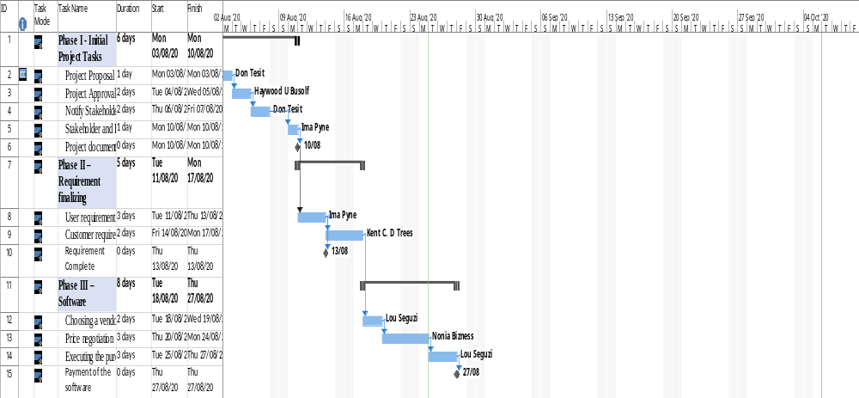
Figure 1: Gantt chart

Budget Cost
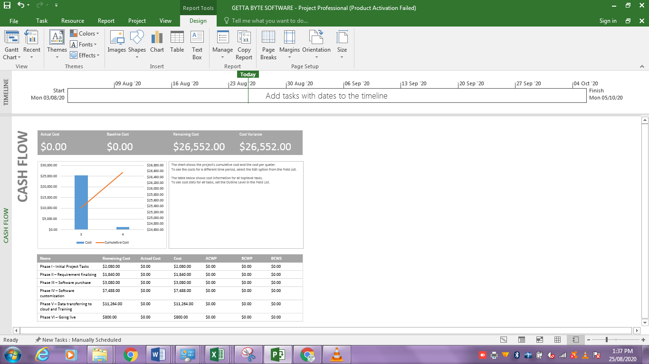
Figure 2: Budget cost
Resource Overview 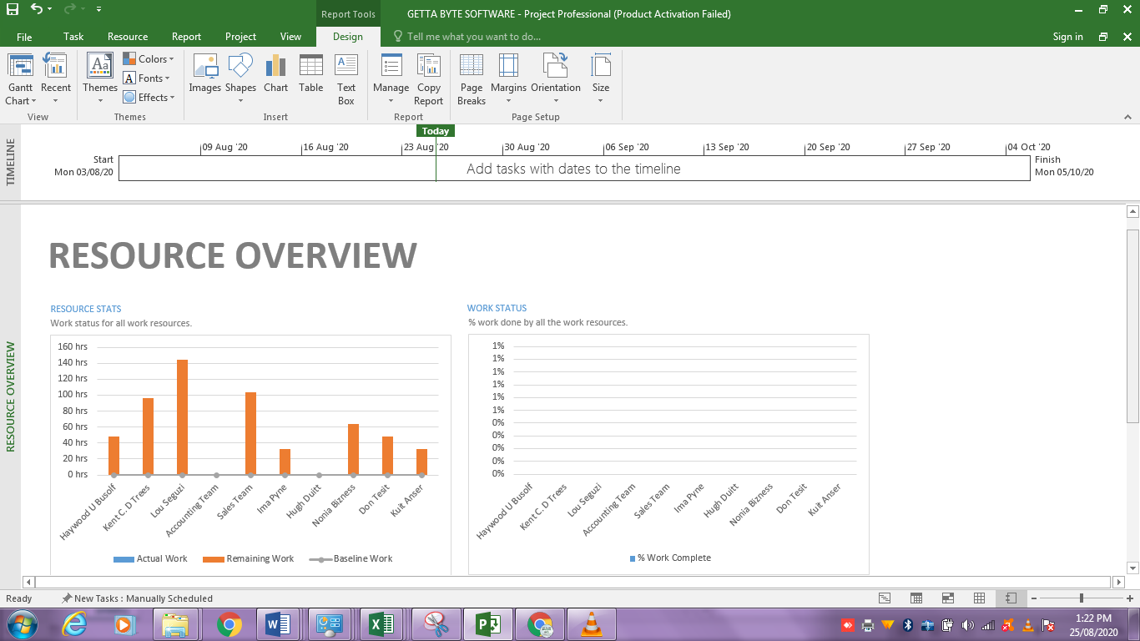
Figure 3: Resource Allocation

SECTION G: Risk Register
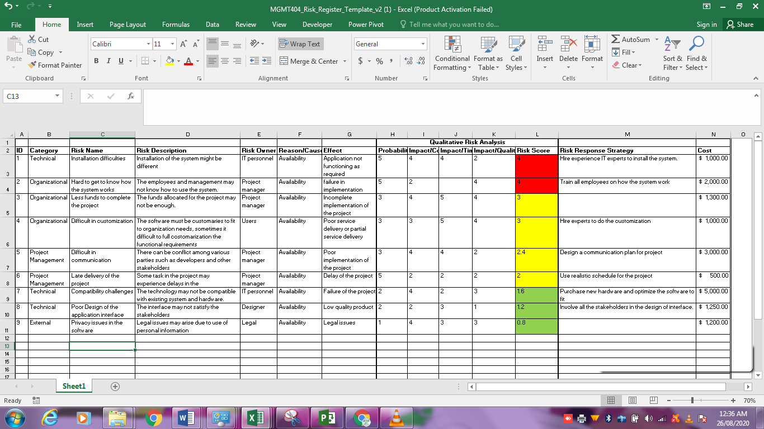

Conclusion

The implementation of the billing system project requires application project management principles. The project was done using the tradition project lifecycle. The project milestones are used to gage project progress. The resources will have work cost estimate for each task in the project. The project stakeholders are responsible, for stakeholders includes the internal and external. The project success is evaluated based acceptance criteria that was set at the beginning of the project (Olechowski et al, 2016). The billing system implementation meets both customer and other stakeholders’ acceptance criteria. Using project management approach, the implementation of the billing system will be successful.

References
Erl, T., Puttini, R., & Mahmood, Z. (2013). Cloud computing : concepts, technology, & architecture. Upper Saddle River, Nj: Prentice Hall.
Holper, P. N., & Csiro (Australia). Division Of Atmospheric Research. (1996). Communication plan. Aspendale, Vic.: Csiro Division Of Atmospheric Research.
Howard Metro, Mininsohn, G., Shellenberger, F., & Institute, M. (1989). Enhancing your billing system. Baltimore: Maryland Institute For Continuing Professional Education Of Lawyers.
‌Hubbard, S. (2003). Selecting and implementing a billing system. London: Chorleywood Consulting.
Olechowski, A., Oehmen, J., Seering, W., & Ben-Daya, M. (2016). The professionalization of risk management: What role can the ISO 31000 risk management principles play?. International Journal of Project Management, 34(8), 1568-1578.
‌Rittinghouse, J. W. (2010). Cloud computing : implementation, management, and security. Florida: Taylor & Francis.

